

Methods Unit 4 Test 4, 2018

(Calculator Free) Name__________________

Time: 22 minutes Marks: 22

Show working in sufficient detail to support your answers. Incorrect answers given without supporting reasoning may not be allocated any marks.

1. [2, 2 marks]

Determine for each (you do not need to simplify):

1. y =

1. y = x2. ln(sin x)

2. [2, 2 marks]

Determine the following:

a)

b) dx

1. [4 marks]

Solve 2x – 1 = 33x, leaving your answer in exact form.

1. [3, 2 marks]

The continuous random variable X is defined by the p.d.f.

f(x) =

1. Determine the exact value of *q*.
2. Determine P(2 < x < 3)

5. [5 marks]

The diagram below shows y = loga(x), y = loga(x + b) and y = loga(x) + c.

Determine a, b and c.

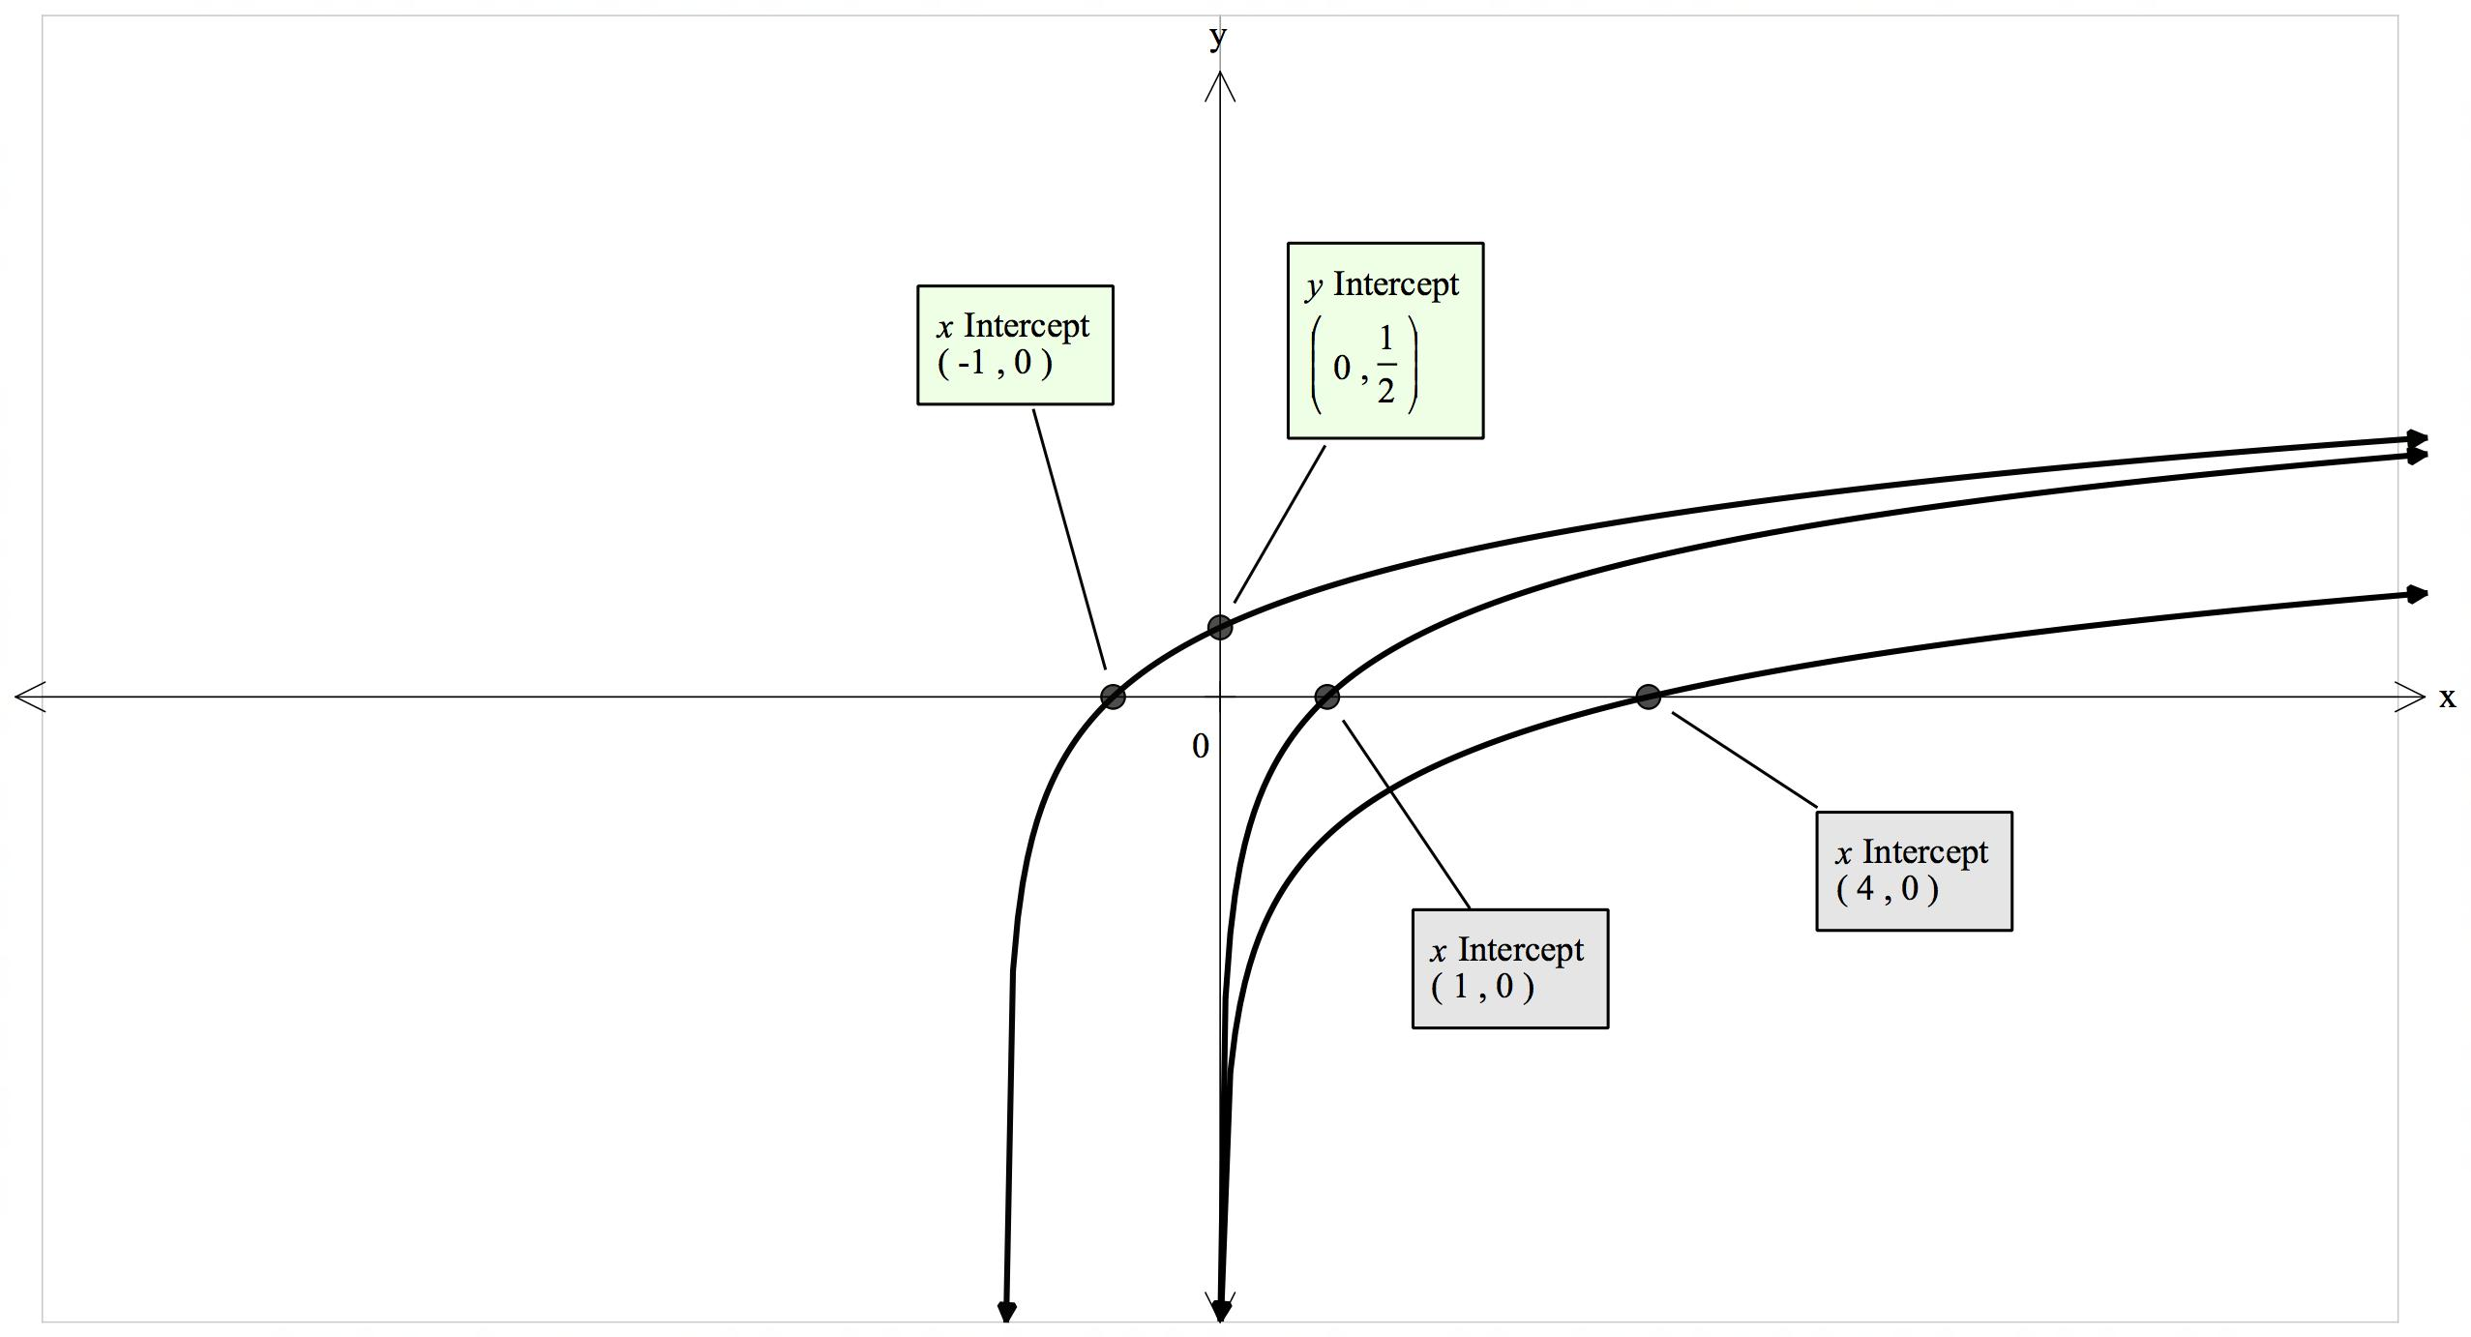

 Methods Unit 4 Test 4, 2018

(Calculator Assumed) Name___________________

Time: 43 minutes Marks: 43

Show working in sufficient detail to support your answers. Incorrect answers given without supporting reasoning may not be allocated any marks.

6. [2, 3, 2, 2 marks]

The serving time, T seconds, for a customer at an ATM is a uniformly distributed random variable, where 50 T 150.

1. Sketch this distribution function below, using appropriate scales on each axis.
2. Find the expected value and standard deviation for this distribution.
3. Evaluate P(T 100 | T 120)
4. What is the probability that exactly 3 of the next 5 customers will require at least 2 minutes to be served?

7. [2, 3, 3, 3 marks]

The life (in years) of a light globe has a p.d.f. which can be modelled by:

f(x) =

1. Determine P(X < 1)
2. Determine P(X < 3)
3. Determine the expected value for this distribution.
4. If you had 1000 globes, how many would you expect to last longer than 3 years?

8. [2, 2, 4 marks]

1. Consider the shaded area shown between the graph of y = ex, the y-axis and y = 2.

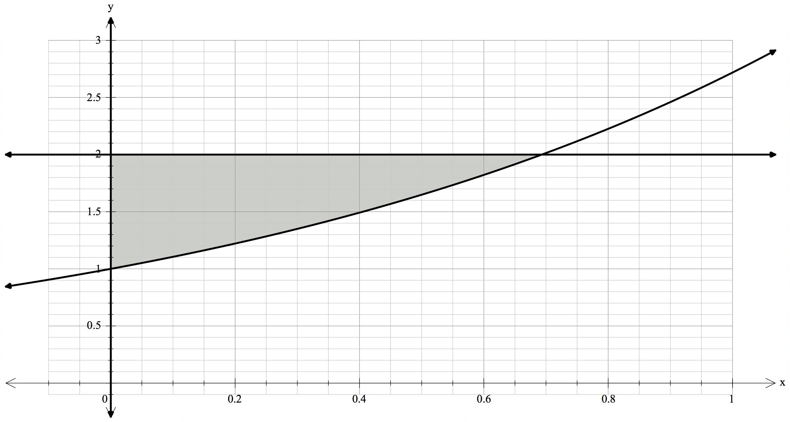

**A**

1. Determine the exact coordinates of point A.
2. Hence, or otherwise, determine the shaded area.
3. If the area between y = ex, the x-axis, the y-axis and x = *k*, where k > 0, is to be equal to 2 square units, determine the exact value of *k*.

9. [1, 4 marks]

1. Determine f ‘(x), given f(x) =
2. Hence, or otherwise, show that = )

10. [3, 1, 2, 2, 2 marks]

A continuous random variable X has a pdf such that f(x) = 0.4e-0.4x defined over interval [0,

a) Show that P(X k) = 1 – e-0.4k

Hence or otherwise determine:

b) P(X 5)

c) P(5 X 6)

c) P(X 6 | X 5)

d) the value of a, given that P(X a) = 0.2